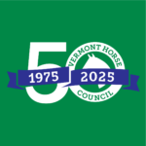
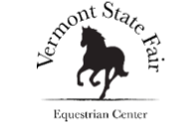
2025
Equine Spring Fling
Schedule of Events
____________

Friday, May 9, 2025
Food vending provided by Pelletier Maple Products

3 pm Gates open for participants & spectators

5:30 pm Gymkhana & Jackpot Barrel Event Main Arena
Champion Award presentation at completion

Saturday, May 10, 2025
Food vending provided by Pelletier Maple Products

7 am Gates open for participants & spectators

9 am Meet & greet Morgan Horses Display Stalls
10 am Tack sale Covered Arena

10 am Vendor Tables Vendor Area

10 am “Pace your Horse” & ½ Mile Track
Distance riding workshop

10 am Jumper schooling rounds Main Arena

10 am Vermont horse council 50th Vendor Area
Celebration

3:30 pm Morgan Extravaganza Event Main Arena

Sunday, May 11, 2025
Food vending provided by Pelletier Maple Products

7 am Gates open for participants and spectators

9 am Open Horse Show Main Arena

10 am Extreme Trail & Obstacle Event Track Infield

10 am Vendor Tables Vendor Area

4 pm Gates Close

